2.01 Ingram Readymix Secured Network

The Ingram Readymix project contains features such as a ledger that maintains integrity, power management of the system and a communication program that transmits data offsite. The ledger is created with the use blockchain to prevent data manipulation. Three sensors are used to provide data for the power management system. The program to transmit data consists of a server that will collect and pass the data to an application for the user to view. This development process is important because it provides reliability and access to data.

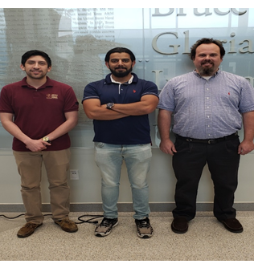

Figure 1: Andres Oliva | Ahmed Al Qaysi | Nicholas Holleman

|  |  |  |
| --- | --- | --- |
| Function | Deliverables | DRI |
| Secure data storage | *Blockchain ledger of sensor data from the server that will be accessed through a call function from the user interface.* | *Nicholas* |
| Interactive user interface | *Interactive user interface that will be accessed through a local Raspberry Pi displayed on an LCD screen.* | *Ahmed* |
| *Implementation of power monitoring data through a python code call function.* | *Andres* |
| Power monitoring | *Data analysis visualization of voltage and current generation/usage. Accessed through python code implemented into user interface.* | *Andres* |
| *Implementation of three voltage and current sensors for collection of data on power components in the system.* | *Andres* |
| Secure communication | *Encrypted TCP communication with clients and a server on an existing network.* | *Nicholas* |
| *Remote access to sensor database via TCP.* | *Nicholas* |